Practical no. 13
Name :- Danish Altaf Solkar Enrolment no. :-24111590805
Class :- CO3K – B Subject :- OOP
Aim :- Define all the classes to represent hierarchy and define functions to retrieve individual information as and when required.
Program :-
#include<iostream.h>
#include<conio.h>
class Staff{
public:
int code;
char name[30];
};
class Teacher:public Staff{
public:
char subject[40];
char publication[50];
void t_accept(){
cout<<"\nEnter Details of Teacher :- ";
cout<<"\nEnter your Code :- ";
cin>>code;
cout<<"\nEnter your Name :- ";
cin>>name;
cout<<"\nEnter your Subject :- ";
cin>>subject;
cout<<"\nEnter your Publication :- ";
cin>>publication;
}
void t_display(){
cout<<"Details of Teacher :- ";
cout<<"\nCode :- "<<code;
cout<<"\nName :- "<<name;
cout<<"\nSubject :- "<<subject;
cout<<"\nPublication :- "<<publication;
}
};
class Officer: public Staff{
public:
char grade;
void o_accept(){
cout<<"\nEnter details of Officer :- ";
cout<<"\nEnter your Code :- ";
cin>>code;
cout<<"\nEnter your Name :- ";
cin>>name;
cout<<"\nEnter your Grade :- ";
cin>>grade;
}
void o_display(){
cout<<"\nDetails of Officer :- ";
cout<<"\nCode :- "<<code;
cout<<"\nName :- "<<name;
cout<<"\nGrade :- "<<grade;
}
};
class Typist: public Staff{
public:
int speed;
};
class Regular:public Typist{
public:
int salary;
void r_accept(){
cout<<"\nEnter details of Regular Typist :- ";
cout<<"\nEnter your Code :- ";
cin>>code;
cout<<"\nEnter your Name :- ";
cin>>name;
cout<<"\nEnter your Typing Speed :- ";
cin>>speed;
cout<<"\nEnter your Salary :- ";
cin>>salary;
}
void r_display(){
cout<<"\nDetails of Regular Typist :- ";
cout<<"\nCode :- "<<code;
cout<<"\nName :- "<<name;
cout<<"\nTyping Speed :- "<<speed;
cout<<"\nSalary :- "<<salary;
}
};
class Casual: public Typist{
public:
int daily_wages;
void c_accept(){
cout<<"\nEnter details of Casual Typist :- ";
cout<<"\nEnter your Code :- ";
cin>>code;
cout<<"\nEnter your Name :- ";
cin>>name;
cout<<"\nEnter your Typing Speed :- ";
cin>>speed;
cout<<"\nEnter your Daily Wages :- ";
cin>>daily_wages;
}
void c_display(){
cout<<"\nDetails of Casual Typist :- ";
cout<<"\nCode :- "<<code;
cout<<"\nName :- "<<name;
cout<<"\nTyping Speed :- "<<speed;
cout<<"\nDaily Wages :- "<<daily_wages;
}
};
void main(){
Teacher t;
Officer o;
Regular r;
Casual c;
clrscr();
t.t_accept();
t.t_display();
getch();
clrscr();
o.o_accept();
o.o_display();
getch();
clrscr();
r.r_accept();
r.r_display();
getch();
clrscr();
c.c_accept();
c.c_display();
getch();
}

Output :- 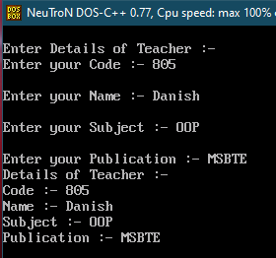

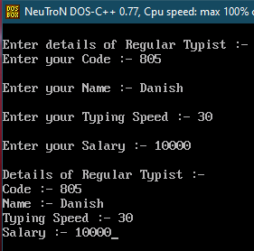

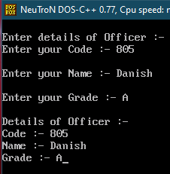
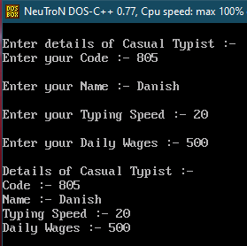

Aim :- WAP in C++ to implement given class hierarchy.
Program :-
#include<iostream.h>
#include<conio.h>
class Player{
public:
char name[50];
int matches;
};
class Batsman:public Player{
public:
int total_score;
int per_match_score;
int average;
void accept(){
cout<<"\nEnter details of Batsman :- ";
cout<<"\nEnter the Name :- ";
cin>>name;
cout<<"\nEnter the number of Matches :- ";
cin>>matches;
cout<<"\nEnter the Total Score :- ";
cin>>total_score;
cout<<"\nEnter the Score per Match :- ";
cin>>per_match_score;
}
void calculate_Average(){
int avg;
avg=(total_score+per_match_score)/2;
average=avg;
}
void display(){
cout<<"\nBatsman details :- ";
cout<<"\nName :- "<<name;
cout<<"\nNumber of Matches :- "<<matches;
cout<<"\nTotal Score :- "<<total_score;
cout<<"\nScore per Match :- "<<per_match_score;
cout<<"\nAverage :- "<<average;
}
};
class Bowler:public Player{
public:
int no_of_wickets;
void b_accept(){
cout<<"\nEnter details of Bowler :- ";
cout<<"\nEnter the Name :- ";
cin>>name;
cout<<"\nEnter the Number of Matches :- ";
cin>>matches;
cout<<"\nEnter the Number of Wickets :- ";
cin>>no_of_wickets;
}
void b_display(){
cout<<"\nBowler details :- ";
cout<<"\nName :- "<<name;
cout<<"\nNumber of Matches :- "<<matches;
cout<<"\nNumber of Wickets :- "<<no_of_wickets;
}
};
void main(){
Batsman b1;
Bowler b2;
clrscr();
b1.accept();
b1.calculate_Average();
b1.display();
getch();
clrscr();
b2.b_accept();
b2.b_display();
getch();
}

Output :-
